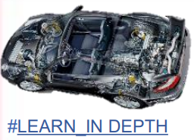**Ain Shams University**

**Faculty of Engineering**

**Mechatronics Engineering Department**

**Mastering Embedded System Online Diploma** [**www.learn-in-depth.com**](http://www.learn-in-depth.com)

**First Term (Final Project 1)**

**“Pressure Detection System”**

**Eng. Omar Ahmed Dawood**

**My Profile: <** [oa0578222@gmail.com (learn-in-depth.com)](https://www.learn-in-depth.com/online-diploma/oa0578222%40gmail.com)**>**

Contents

**1** **Introduction** 3

1.1 Design Sequence 3

**2** **Requirements of Client (Case Study)** 3

**3** **Method** 4

**4** **Requirements Diagram** 5

**5** **Space Exploration** 5

**6** **System Analysis** 6

6.1 Use Case Diagram 6

6.2 Activity Diagram 6

6.3 Sequence Diagram 7

**7** **System Design** 8

7.1 All System 8

7.2 Pressure Sensor Block 8

7.3 Main Alg Block 9

7.4 LED Indicator Block 9

7.5 Alarm Monitoring Block 10

**8** **System Design Simulation** 11

8.1 Pressure Less than 20 11

8.2 Pressure More than 20 11

**9** **Implementation** 12

9.1 Pressure Sensor 12

9.2 Main Alg 12

9.3 Alarm Monitoring 13

9.4 LED Indicator 13

9.5 Linker script file 14

9.6 Startup file 15

**10** **Simulation on proteus** 16

10.1 Hardware 16

10.2 Pressure less than 20 bar 16

10.3 Pressure more than 20 bar 17

# **Introduction**

* in this project we will make Pressure Detection sensor that detect high pressure in the cabin of plane.
* Occur Alarm when Pressure exceeds on 20 bar.
* Alarm will continue for 60 seconds.
* We will Apply Design sequence to make this project.
* We will use stm32f103 microcontroller.

## Design Sequence

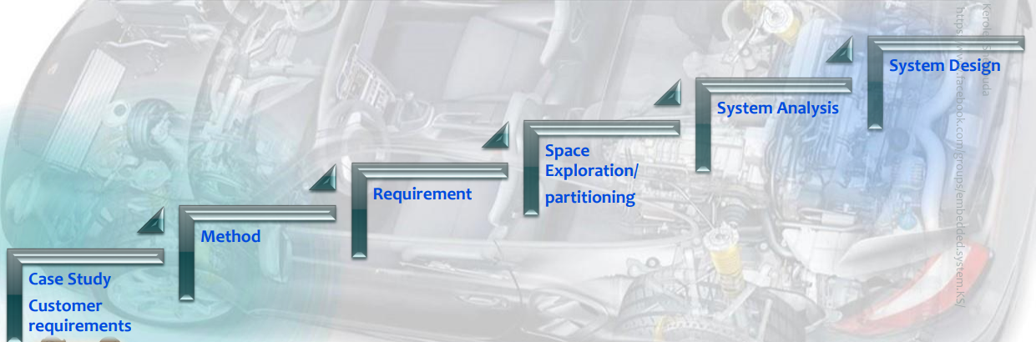

Design Sequence

# **Requirements of Client (Case Study)**

A” client” expects you to deliver the software of the following system:

* Specification (from the client)
* A pressure controller informs the crew of a cabin with an alarm when the pressure exceeds 20 bars in the cabin
* The alarm duration equals 60 seconds.

# **Method**

* We will Apply V Model.

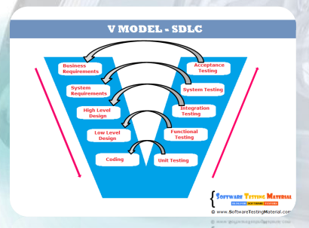

# **Requirements Diagram**

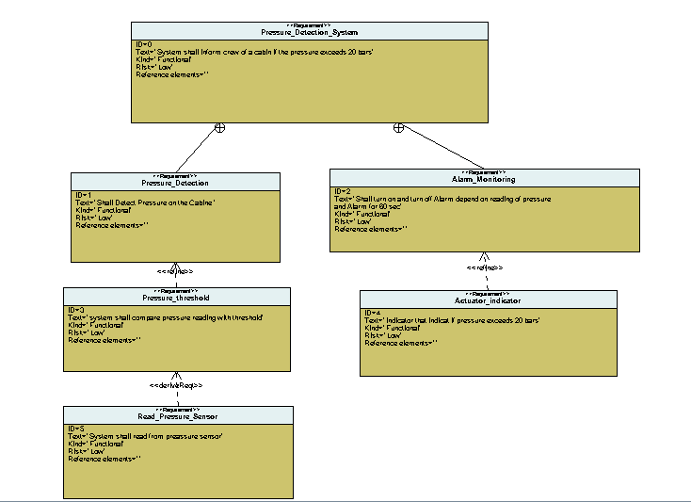

# **Space Exploration**

* 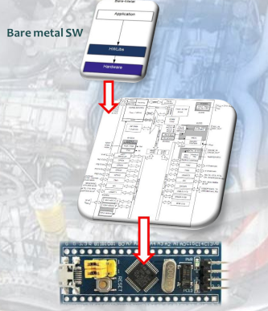We will use only one ECU with one CPU Cortex M3 (STM32f103) Microcontroller.

# **System Analysis**

## Use Case Diagram

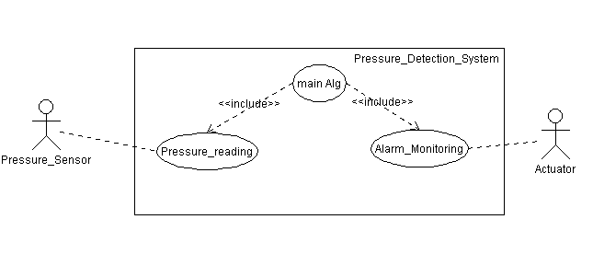

## Activity Diagram

## Sequence Diagram

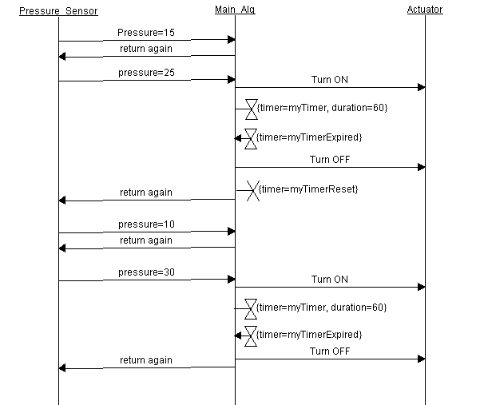

# **System Design**

## All System

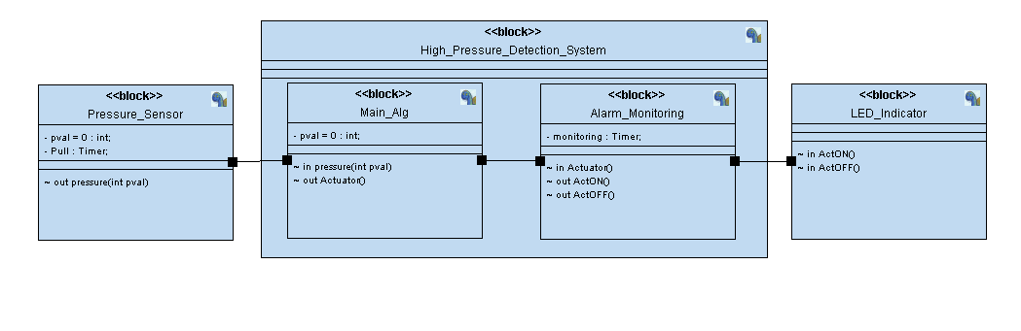

## Pressure Sensor Block

## Main Alg Block

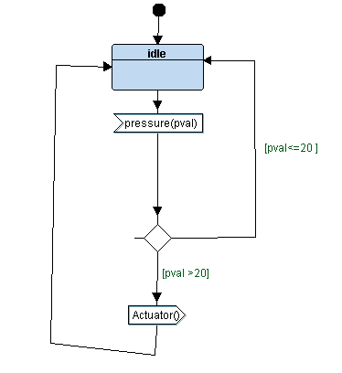

## LED Indicator Block

## Alarm Monitoring Block

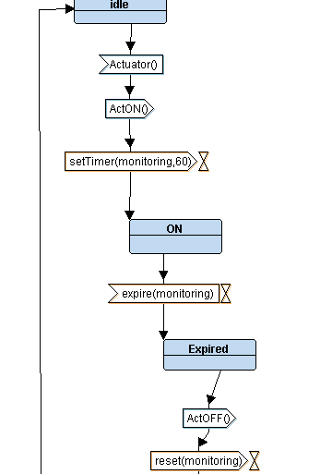

# **System Design Simulation**

## Pressure Less than 20

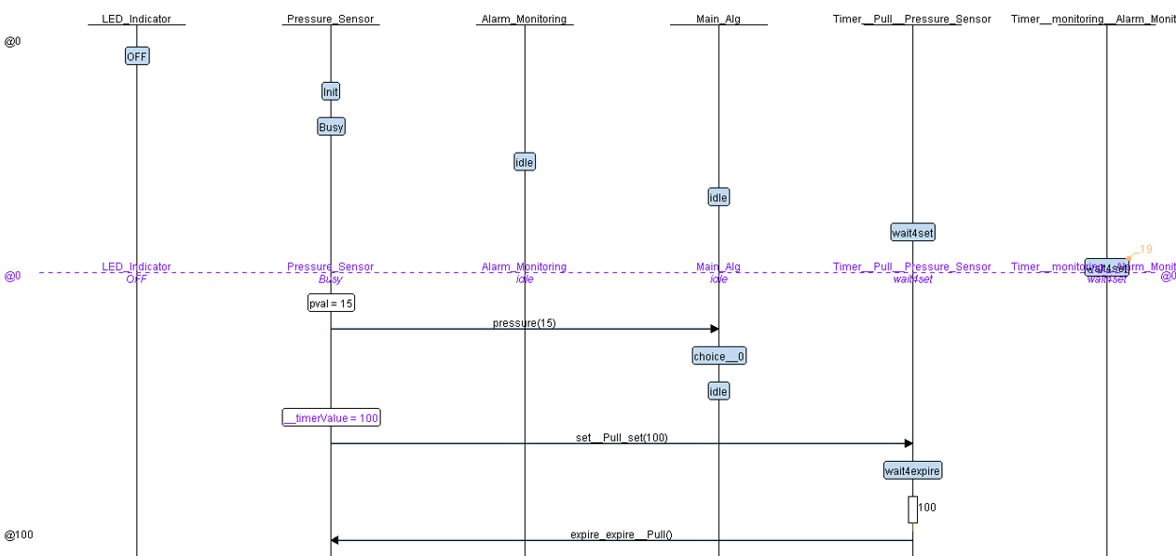

## Pressure More than 20

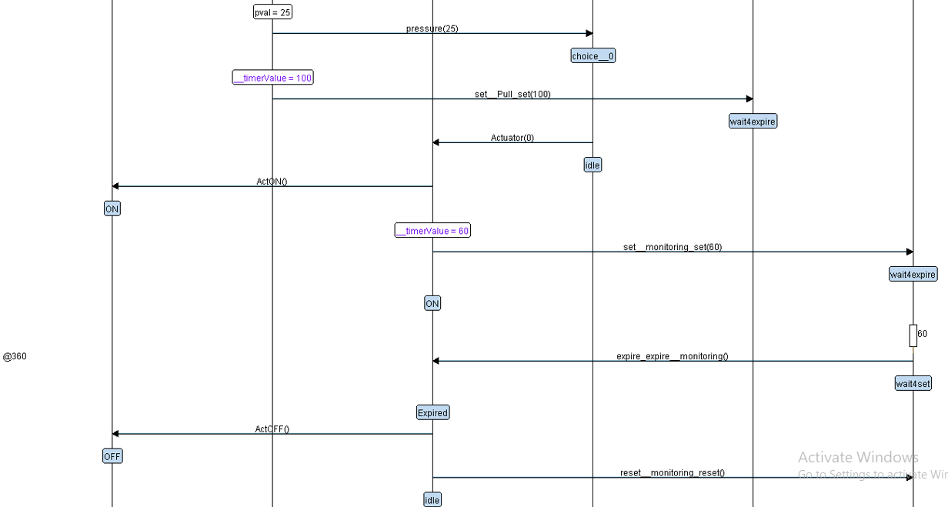

# **Implementation**

## Pressure Sensor

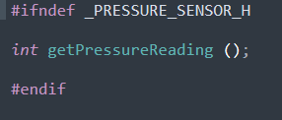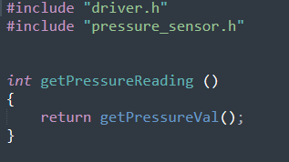

**.h file**

**.c file**

## Main Alg

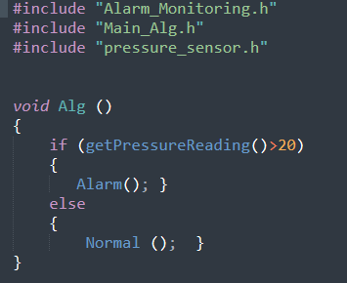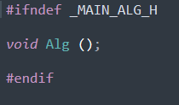

**.h file**

**.c file**

## Alarm Monitoring

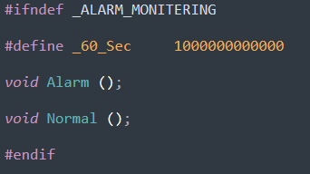

**.h file**

**.c file**

## LED Indicator

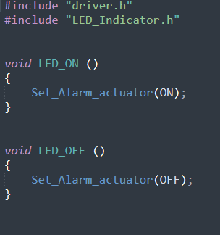

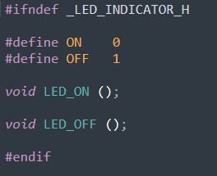

**.h file**

**.c file**

## Linker script file

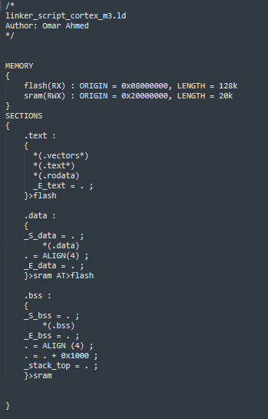

## Startup file

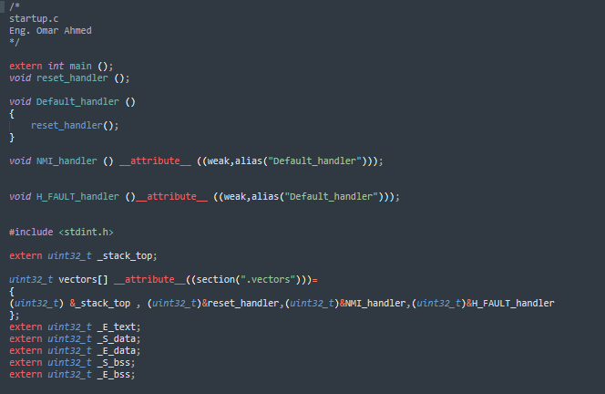

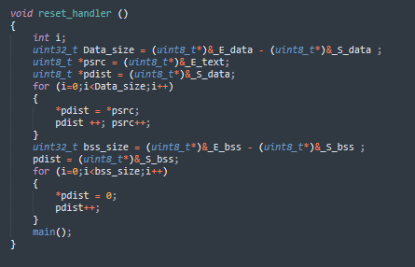

# **Simulation on proteus**

## Hardware

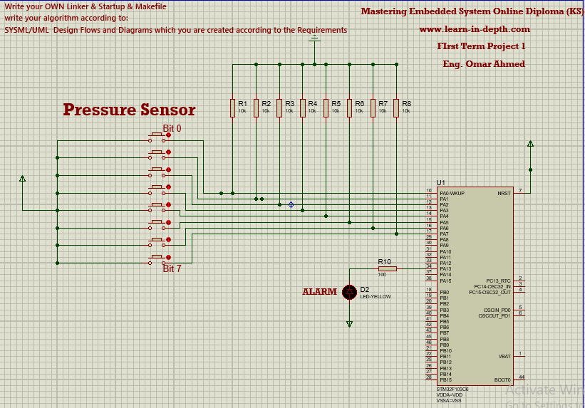

## Pressure less than 20 bar

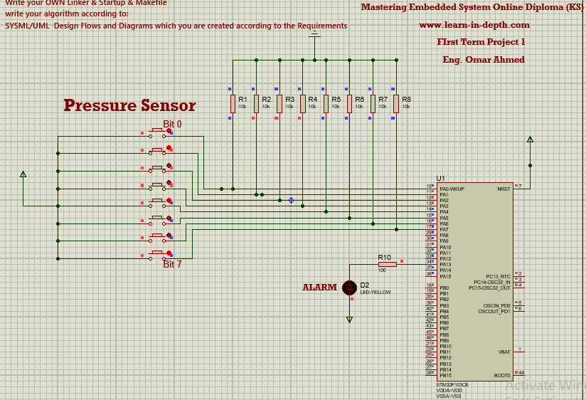

## Pressure more than 20 bar

